1. INP3201 reference kit
2. 2 PIN UART cable with 6 wires
3. Talaria TWO SWD cable
4. USB Type C to Type A power cable
5. INP3000 programmer board

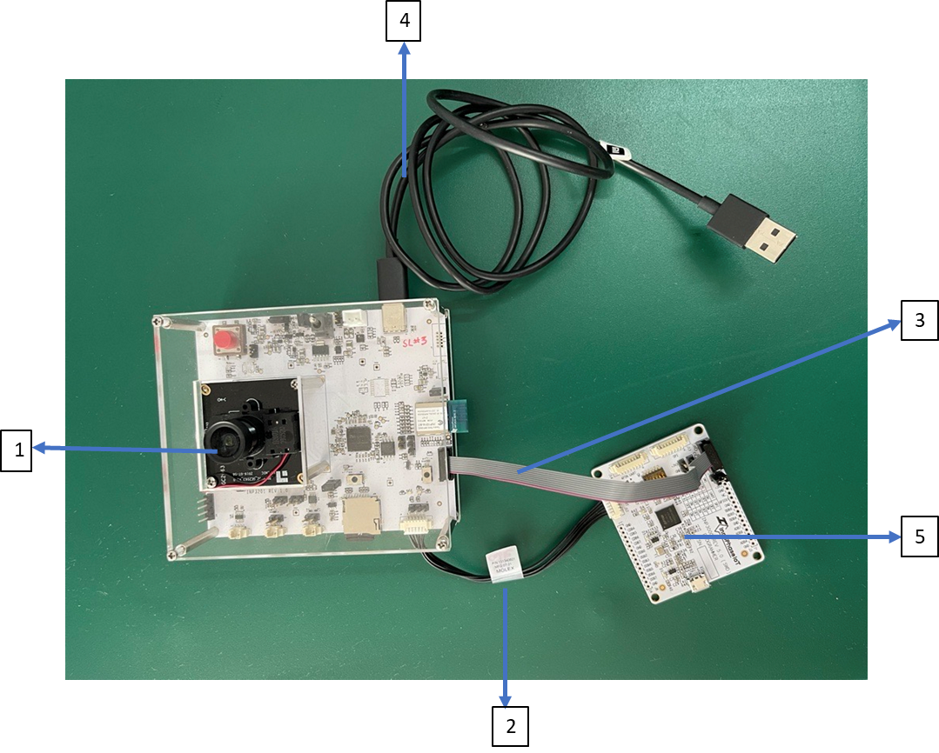

Figure 1: INP301x package contents